Qualification aims and objectives:
- understand and apply the fundamental principles and concepts of Computer Science, including abstraction, decomposition, logic, algorithms, and data representation
- analyse problems in computational terms through practical experience of solving such problems, including designing, writing and debugging programs
- think creatively, innovatively, analytically, logically and critically
- understand the components that make up digital systems, and how they communicate with one another and with other systems
- understand the impacts of digital technology to the individual and to wider society
- apply mathematical skills relevant to Computer Science.

Key features of OCR GCSE Computing course:
- Consists of two papers, one focusing on computer systems and one with a focus on programming, computational thinking, and algorithms. Both papers have identical weighting and mark allocations
- The course has been designed to transition seamlessly into Computer Science at AS Level and/or A Level
- Developing valuable thinking and programming skills that are extremely attractive in the modern workplace
- Develop an understanding of computational thinking and how to apply it through a chosen programming language

Content overview: J277/01: Computer systems.

Topics:
- 1.1 Systems architecture
- 1.2 Memory and storage
- 1.3 Computer networks, connections and protocols
- 1.4 Network security
- 1.5 Systems software
- 1.6 Ethical, legal, cultural and environmental impacts of digital technology

Assessment:
- Written paper: 1 hour and 30 minutes, 50% of total GCSE, 80 marks. This is a non-calculator paper
- This paper consists of multiple-choice questions, short response questions and extended response questions.

Content overview: J277/02: Computational thinking, algorithms and programming.

Topics:
- 2.1 Algorithms
- 2.2 Programming fundamentals
- 2.3 Producing robust programs
- 2.4 Boolean logic
- 2.5 Programming languages and Integrated Development Environments

Assessment:
- Written paper: 1 hour and 30 minutes, 50% of total GCSE, 80 marks. This is a non-calculator paper
- This paper has two sections: Section A and Section B
- In Section B, questions assessing students’ ability to write or refine algorithms must be answered using either the OCR Exam Reference Language or the high-level programming language they are familiar with, such as Python.

Practical Programming
All students must be given the opportunity to undertake a programming task(s), either to a specification or to solve a problem (or problems), during their course of study. Students may draw on some of the content in both components when engaged in Practical Programming.

Year 10 Computing

Week | Term | Topic | Learning Objectives
1 | Autumn Term 1 | The purpose of the CPU:  The fetch-execute-cycle | - What actions occur at each stage of the fetch-execute cycle  - The role/purpose of each component and what it manages, stores, or controls during the fetch-execute cycle  - The purpose of each register, what it stores (data or address)  - The difference between storing data and an address
2 |  | Common CPU components and their function:  - ALU (Arithmetic Logic Unit)  - CU (Control Unit)  - Cache  - Registers
3 |  | Von Neumann architecture:  - MAR (Memory Address Register)  - MDR (Memory Data Register)  - Program Counter Accumulator
4 |  | How common characteristics of CPUs affect their performance:  - Clock speed  - Cache size  - Number of cores | - Understanding of each characteristic as listed  - The effects of changing any of the common characteristics on system performance, either individually or in combination
5 |  | Embedded systems:  - The purpose and characteristics of embedded systems  - Examples of embedded systems | - What embedded systems are  - Typical characteristics of embedded systems  - Familiarity with a range of different embedded systems
6 |  | Primary storage (memory):  - The need for primary storage  - The difference between RAM and ROM  - The purpose of ROM in a computer system  - The purpose of RAM in a computer system  - Virtual memory | - Why computers have primary storage  - How this usually consists of RAM and ROM  - Key characteristics of RAM and ROM  - Why virtual memory may be needed in a system  - How virtual memory works§ Transfer of data between RAM and HDD when RAM is filled
7 |  | Secondary storage:  - The need for secondary storage  - Common types of storage/  - Optical  - Magnetic  - Solid state  - Suitable storage devices and storage media for a given application  - The advantages and disadvantages of different storage devices and storage media relating to these characteristics:  - Capacity  - Speed  - Portability  - Durability  - Reliability  - Cost | - Why computers have secondary storage  - Recognise a range of secondary storage devices/media  - Differences between each type of storage device/medium  - Compare advantages/disadvantages for each storage device  - Be able to apply their knowledge in context within scenarios
8 |  | Autumn Term 1 assessment
9 | Autumn Term 2 | The units of data storage  - Bit  - Nibble (4 bits)  - Byte (8 bits)  - Kilobyte (1,000 bytes or 1 KB)  - Megabyte (1,000 KB)  - Gigabyte (1,000 MB)  - Terabyte (1,000 GB)  - Petabyte (1,000 TB)  - How data needs to be converted into a binary format to be processed by a computer  - Data capacity and calculation of data capacity requirements | - Why data must be stored in binary format  - Familiarity with data units and moving between each  - Data storage devices have different fixed capacities  - Calculate required storage capacity for a given set of files  - Calculate file sizes of sound, images and text files  - sound file size = sample rate x duration (s) x bit depth  - image file size = colour depth x image height (px) x image width (px)  - text file size = bits per character x number of characters
10 |  | Data storage: numbers  - How to convert positive denary whole numbers to binary numbers (up to and including 8 bits) and vice versa  - How to add two binary integers together (up to and including8 bits) and explain overflow errors which may occur  - How to convert positive denary whole numbers into 2-digit hexadecimal numbers and vice versa  - How to convert binary integers to their hexadecimal equivalents and vice versa  - Binary shifts | - Denary number range 0 – 255  - Hexadecimal range 00 – FF  - Binary number range 00000000 – 11111111  - Understanding of the terms ‘most significant bit’, and ‘least significant bit’  - Conversion of any number in these ranges to another number base  - Ability to deal with binary numbers containing between 1 and 8 bit e.g., 11010 is the same as 00011010  - Understand the effect of a binary shift (both left or right) on a number  - Carry out a binary shift (both left and right)
11 |  | Data storage: characters  - The use of binary codes to represent characters  - The term ‘character set’  - The relationship between the number of bits per character in a character set, and the number of characters which can be represented, e.g.:  - ASCII  - UNICODE | - How characters are represented in binary  - How the number of characters stored is limited by the bits available  - The differences between and impact of each character set  - Understand how character sets are logically ordered, e.g., the code for ‘B’ will be one more than the code for ‘A’  - Binary representation of ASCII in the exam will use 8 bits
12 |  | Data storage: images  - How an image is represented as a series of pixels, represented in binary  - Metadata  - The effect of colour depth and resolution on:  - The quality of the image  - The size of an image file | - Each pixel has a specific colour, represented by a specific code  - The effect on image size and quality when changing colour depth and resolution  - Metadata stores additional image information (e.g., height, width, etc.)
13 |  | Data storage: sound  - How sound can be sampled and stored in digital form ̈ The effect of sample rate, duration and bit depth on:  - The playback quality  - The size of a sound file | - Analogue sounds must be stored in binary  - Sample rate – measured in Hertz (Hz)  - Duration – how many seconds of audio the sound file contains  - Bit depth – number of bits available to store each sample (e.g., 16-bit)
14 |  | Compression  - The need for compression  - Types of compression:  - Lossy  - Lossless | - Common scenarios where compression may be needed  - Advantages and disadvantages of each type of compression  - Effects on the file for each type of compression
15 |  | Autumn Term 2 assessment
16 | Spring Term 1 | Networks and topologies  Types of network:  - LAN (Local Area Network)  - WAN (Wide Area Network)  - Factors that affect the performance of networks  - The different roles of computers in a client-server and a peer-to-peer network | - The characteristics of LANs and WANs including common examples of each  - Understanding of different factors that can affect the performance of a network, e.g.:  - Number of devices connected  - Bandwidth
17 |  | Hardware needed to connect stand-alone computers into a Local Area Network:  - Wireless access points  - Routers  - Switches  - NIC (Network Interface Controller/Card)  - Transmission media  - The different roles of computers in a client-server and a peer-to-peer network | - The tasks performed by each piece of hardware
18 |  | - The Internet as a worldwide collection of computer networks:  - DNS (Domain Name Server)  - Hosting  - The Cloud  - Web servers and clients  Factors that affect the performance of networks and modes of connection:  - Wired  - Ethernet  - Wireless  - Wi-Fi  - Bluetooth  - Encryption | - The concept of the Internet as a network of computer networks  - A Domain Name Service (DNS) is made up of multiple Domain Name Servers  - A DNS’s role in the conversion of a URL to an IP address  - The concept of the Internet as a network of computer networks  - A Domain Name Service (DNS) is made up of multiple Domain Name Servers  - A DNS’s role in the conversion of a URL to an IP address  - Concept of servers providing services (e.g. Web server " Web pages, File server " file storage/retrieval)  - Concept of clients requesting/using services from a server  - The Cloud: remote service provision (e.g. storage, software, processing)  - Advantages and disadvantages of the Cloud  - Advantages and disadvantages of the Star and Mesh topologies  - Apply understanding of networks to a given scenario  - Compare benefits and drawbacks of wired versus wireless connection  - Recommend one or more connections for a given scenario  - The principle of encryption to secure data across network connections  IP addressing and the format of an IP address (IPv4 and IPv6)  - A MAC address is assigned to devices; its use within a network  - The principle of a standard to provide rules for areas of computing  - Standards allows hardware/software to interact across different manufacturers/producers  - The principle of a (communication) protocol as a set of rules for transferring data  - That different types of protocols are used for different purposes
19 |  | Network protocols / standards including:  - TCP/IP (Transmission Control Protocol/Internet Protocol)  - HTTP (Hyper Text Transfer Protocol)  - HTTPS (Hyper Text Transfer Protocol Secure)  - FTP (File Transfer Protocol)  - POP (Post Office Protocol)  - IMAP (Internet Message Access Protocol)  - SMTP (Simple Mail Transfer Protocol)  - The concept of layers | - The basic principles of each protocol i.e. its purpose and key features  - How layers are used in protocols, and the benefits of using layers; for a teaching example, please refer to the 4-layer TCP/IP model
20 |  | Threats to network security and computer systems  - Malware  - Social engineering, e.g., phishing, people as the ‘weak point  - Brute-force attacks  - Denial of service attacks  - Data interception and theft  - The concept of SQL injection  Common prevention risks  - Penetration testing  - Anti-malware software  - Firewalls  - User access levels  - Passwords  - Encryption  - Physical security | - Threats posed to devices/systems  - Knowledge/principles of each form of attack including:  - How the attack is used  - The purpose of the attack  - Understanding of how to limit the threats posed in 1.4.1  - Understanding of methods to remove vulnerabilities  - Knowledge/principles of each prevention method:  - What each prevention method may limit/prevent  - How it limits the attack
21
21 |  | Spring Term 1 assessment
22 | Spring Term 2 | The purpose and function of operating systems:  - User interface  - Memory management and multi-tasking  - Peripheral management and drivers  - User management  - File management | - What each function of an operating system does  - Features of a user interface  - Memory management, e.g. the transfer of data between memory, and how this allows for multitasking  - Understand that:  - Data is transferred between devices and the processor  - This process needs to be managed  - User management functions, e.g.:  - Allocation of an account  - Access rights  - Security, etc.  - File management, and the key features, e.g.:  - Naming  - Allocating to folders  - Moving files  - Saving, etc.
23 |  | The purpose and functionality of utility software | - Understand that computers often come with utility software, and how this performs housekeeping tasks  - Purpose of the identified utility software and why it is required
24 |  | Utility system software: encryption
25 |  | Utility software: defragmentation
26 |  | Utility software: data compression
27 |  | Spring Term 2 assessment
28 | Summer Term 1 | Ethical issues | - Technology introduces ethical, legal, cultural, environmental and privacy issues  - Knowledge of a variety of examples of digital technology and how this impacts society  - An ability to discuss the impact of technology based around the issues listed  - The purpose of each piece of legislation and the specific actions it allows or prohibits  - The need to license software and the purpose of a software licence  - Features of open source (providing access to the source code and the ability to change the software)  - Features of proprietary (no access to the source code, purchased commonly as off-the-shelf)  - Recommend a type of licence for a given scenario including benefits and drawbacks
29 |  | Legal issues
30 |  | Cultural issues
31 |  | Environmental issues
32 |  | Privacy issues
33 |  | Summer Term 1 assessment
34 | Summer Term 2 | The Data Protection Act 2018
35 |  | The Computer Misuse Act 1990
36 |  | Copyrights Designs and Patents Act 1988
37 |  | Software licences (i.e., open source and proprietary)
38 |  | Misinformation
39 |  | Summer Term 2 Assessment

Year 11 Computing: Computational Thinking, algorithms and programming (J277/02)

Week | Term | Topic | Learning Objectives
1 | Autumn Term 1 | Principles of computational thinking:  - Abstraction  - Decomposition  - Algorithmic thinking | - Understanding of these principles and how they are used to define and refine problems
2 |  | Algorithms: Identify inputs, processes and outputs for a problem | - Produce simple diagrams to show:  - The structure of a problem  - Subsections and their links to other subsections
3 |  | Algorithms: Structure diagrams
4 |  | Algorithms: Flowcharts
5 |  | Algorithms: Pseudocode  - Reference language/high-level programming language  - Identify common errors | - Complete, write or refine an algorithm using the techniques listed  - Identify syntax/logic errors in code and suggest fixes
6 |  | Trace tables | - Create and use trace tables to follow an algorithm
7 |  | - Standard searching algorithms  - Binary search  - Linear search  - Standard sorting algorithms  - Bubble sort  - Merge sort  - Insertion sort | - Understand the main steps of each algorithm  - Understand any pre-requisites of an algorithm  - Apply the algorithm to a data set  - Identify an algorithm if given the code or pseudocode for it
8 |  | Autumn Term 1 assessment
9 | Autumn Term 2 | Programming: The use of variables, constants, operators, inputs, outputs and assignments | - Practical use of the techniques in a high-level language within the classroom  - Understanding of each technique  - Recognise and use the following operators:  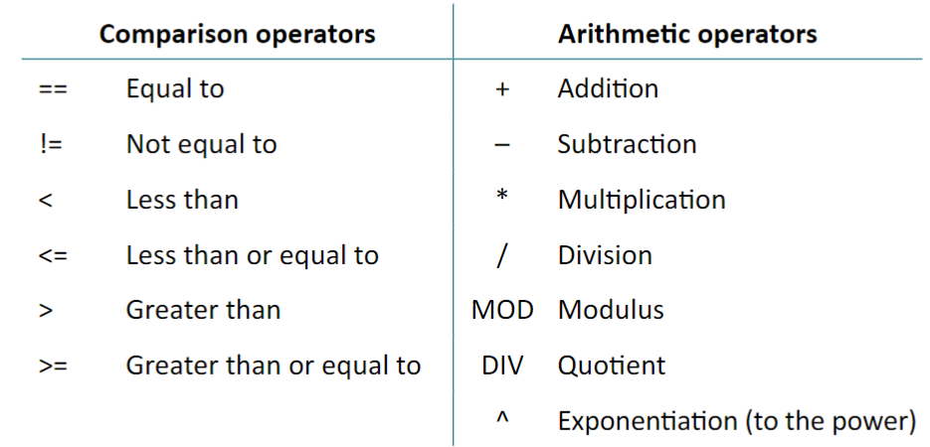
10 |  | Programming: sequence and selection
11 |  | Programming: iteration (count and controlled loops)
12 |  | Programming: arithmetic operators and Boolean operators AND, OR and NOT.
13 |  | Programming tasks using different data types:  - Integer  - Real  - Boolean  - Character and string  - Casting | - Practical use of the data types in a high-level language within the classroom  - Ability to choose suitable data types for data in a given scenario  - Understand that data types may be temporarily changed through casting, and where this may be useful
14 |  | Programming task:  - How to use sub programs (functions and procedures) to produce structured code  - Random number generation | - The use of functions  - The use of procedures  - Where to use functions and procedures effectively  - Be able to create and use random numbers in a program
15 |  | Autumn Term 2 assessment
16 | Spring Term 1 | Arrays  - The use of arrays (or equivalent) when solving problems, including both one-dimensional (1D) and two-dimensional arrays (2D) | - Arrays as fixed length or static structures  - Use of 2D arrays to emulate database tables of a collection of fields, and records
17 |  | SQL:  - The use of basic string manipulation  - The use of basic file handling operations:  - Open  - Read  - Write  - Close  - The use of records to store data  - The use of SQL to search for data | - SQL commands:  - SELECT  - FROM  - WHERE
18 |  | Defensive design considerations  - Anticipating misuse  - Authentication  - Input validation | - Understanding of the issues a programmer should consider to ensure that a program caters for all likely input values  - Understanding of how to deal with invalid data in a program  - Authentication to confirm the identity of a user  - Practical experience of designing input validation and simple authentication (e.g., username and password)
19 |  | Maintainability:  - Use of sub programs  - Naming conventions  - Indentation  - Commenting | - Understand why commenting is useful and apply this appropriately
20 |  | Testing:  - The purpose of testing  - Types of testing:  - Iterative  - Final / terminal  - Identify syntax and logic errors  - Selecting and using suitable test data:  - Normal  - Boundary  - Invalid / erroneous | - The difference between testing modules of a program during development and testing the program at the end of production  - Syntax errors as errors which break the grammatical rules of the programming language and stop it from being run/translated  - Logic errors as errors which produce unexpected output  - Normal test data as data which should be accepted by a program without causing errors  - Boundary test data as data of the correct type which is on the very edge of being valid  - Invalid test data as data of the correct data type which should be rejected by a computer system  - Erroneous test data as data of the incorrect data type which should be rejected by a computer system  - Ability to identify suitable test data for a given scenario  - Ability to create/complete a test plan
21 |  | Spring Term 1 assessment
22 | Spring Term 2 | - Characteristics and purpose of different levels of programming language:  - High-level languages  - Low-level languages  - The purpose of translators  - The characteristics of a compiler and an interpreter | - The differences between high- and low-level programming languages  - The need for translators  - The differences, benefits and drawbacks of using a compiler or an interpreter
23 |  | The Integrated Development Environment  - Common tools and facilities available in an Integrated Development Environment (IDE):  - Editors  - Error diagnostics  - Run-time environment  - Translators | - Knowledge of the tools that an IDE provides  - How each of the tools and facilities listed can be used to help a programmer develop a program  - Practical experience of using a range of these tools within at least one IDE
24 |  | Revision
25 |  | Revision
26 |  | Revision
27 |  | Revision
28 | Summer Term 1 | Ethical issues | - Technology introduces ethical, legal, cultural, environmental and privacy issues  - Knowledge of a variety of examples of digital technology and how this impacts society  - An ability to discuss the impact of technology based around the issues listed  - The purpose of each piece of legislation and the specific actions it allows or prohibits  - The need to license software and the purpose of a software licence  - Features of open source (providing access to the source code and the ability to change the software)  - Features of proprietary (no access to the source code, purchased commonly as off-the-shelf)  - Recommend a type of licence for a given scenario including benefits and drawbacks
29 |  | Legal issues
30 |  | Cultural issues
31 |  | Environmental issues
32 |  | Privacy issues
33 |  | Exam skills development
34 | Summer Term 2 | J277/01 exam
35 |  | J277/02 exam
36
37
38
39

Content of Computer systems (J277/01)
1.1 - System Architecture
1.1.1 - Architecture of the CPU
The purpose of the CPU  - The fetch-execute-cycle | Required  - What actions occur at each stage of the fetch-execute cycle  - The role/purpose of each component and what it manages, stores, or controls during the fetch-execute cycle  - The purpose of each register, what it stores (data or address)  - The difference between storing data and an address  Not required  - Knowledge of passing of data between registers in each stage
Common CPU components and their function:
- ALU (Arithmetic Logic Unit)
- CU (Control Unit)
- Cache
- Registers
Von Neumann architecture:
- MAR (Memory Address Register)
- MDR (Memory Data Register)
- Program Counter Accumulator
1.1.2 - CPU Performance
How common characteristics of CPUs affect their performance:  - Clock speed  - Cache size  - Number of cores | Required  - Understanding of each characteristic as listed  - The effects of changing any of the common characteristics on system performance, either individually or in combination
1.1.3 - Embedded Systems
- The purpose and characteristics of embedded systems  - Examples of embedded systems | - Required  - What embedded systems are  - Typical characteristics of embedded systems  - Familiarity with a range of different embedded systems

1.2 - Memory and Storage
1.2.1 - Primary Storage (Memory)
- The need for primary storage  - The difference between RAM and ROM  - The purpose of ROM in a computer system  - The purpose of RAM in a computer system  - Virtual memory | Required  - Why computers have primary storage  - How this usually consists of RAM and ROM  - Key characteristics of RAM and ROM  - Why virtual memory may be needed in a system  - How virtual memory works§ Transfer of data between RAM and HDD when RAM is filled
1.2.2 - Secondary Storage
- The need for secondary storage  - Common types of storage/  - Optical  - Magnetic  - Solid state  - Suitable storage devices and storage media for a given application  - The advantages and disadvantages of different storage devices and storage media relating to these characteristics:  - Capacity  - Speed  - Portability  - Durability  - Reliability  - Cost | Required  - Why computers have secondary storage  - Recognise a range of secondary storage devices/media  - Differences between each type of storage device/medium  - Compare advantages/disadvantages for each storage device  - Be able to apply their knowledge in context within scenarios  Not required  - Understanding of the component parts of these types of storage
1.2.3 - Units
- The units of data storage  - Bit  - Nibble (4 bits)  - Byte (8 bits)  - Kilobyte (1,000 bytes or 1 KB)  - Megabyte (1,000 KB)  - Gigabyte (1,000 MB)  - Terabyte (1,000 GB)  - Petabyte (1,000 TB)  - How data needs to be converted into a binary format to be processed by a computer  - Data capacity and calculation of data capacity requirements | Required  - Why data must be stored in binary format  - Familiarity with data units and moving between each  - Data storage devices have different fixed capacities  - Calculate required storage capacity for a given set of files  - Calculate file sizes of sound, images and text files  - sound file size = sample rate x duration (s) x bit depth  - image file size = colour depth x image height (px) x image width (px)  - text file size = bits per character x number of characters  Alternatives  - Use of 1,024 for conversions and calculations would be acceptable  - Allowance for metadata in calculations may be used
1.2.4 - Data Storage
Numbers  - How to convert positive denary whole numbers to binary numbers (up to and including 8 bits) and vice versa  - How to add two binary integers together (up to and including8 bits) and explain overflow errors which may occur  - How to convert positive denary whole numbers into 2-digit hexadecimal numbers and vice versa  - How to convert binary integers to their hexadecimal equivalents and vice versa  - Binary shifts  Characters  - The use of binary codes to represent characters  - The term ‘character set’  - The relationship between the number of bits per character in a character set, and the number of characters which can be represented, e.g.:  - ASCII  - UNICODE  Images  - How an image is represented as a series of pixels, represented in binary  - Metadata  - The effect of colour depth and resolution on:  - The quality of the image  - The size of an image file  Sound  - How sound can be sampled and stored in digital form ̈ The effect of sample rate, duration and bit depth on:  - The playback quality  - The size of a sound file | Required:  - Denary number range 0 – 255  - Hexadecimal range 00 – FF  - Binary number range 00000000 – 11111111  - Understanding of the terms ‘most significant bit’, and ‘least significant bit’  - Conversion of any number in these ranges to another number base  - Ability to deal with binary numbers containing between 1 and 8 bit e.g., 11010 is the same as 00011010  - Understand the effect of a binary shift (both left or right) on a number  - Carry out a binary shift (both left and right)  Required:  - How characters are represented in binary  - How the number of characters stored is limited by the bits available  - The differences between and impact of each character set  - Understand how character sets are logically ordered, e.g., the code for ‘B’ will be one more than the code for ‘A’  - Binary representation of ASCII in the exam will use 8 bits  Not required:  - Memorisation of character set codes  Required:  - Each pixel has a specific colour, represented by a specific code  - The effect on image size and quality when changing colour depth and resolution  - Metadata stores additional image information (e.g., height, width, etc.)  Required:  - Analogue sounds must be stored in binary  - Sample rate – measured in Hertz (Hz)  - Duration – how many seconds of audio the sound file contains  - Bit depth – number of bits available to store each sample (e.g., 16-bit)
1.2.5 - Compression
- The need for compression  - Types of compression:  - Lossy  - Lossless | Required:  - Common scenarios where compression may be needed  - Advantages and disadvantages of each type of compression  - Effects on the file for each type of compression  Not required:  - Ability to carry out specific compression algorithms

1.3 - Computer Networks and Protocols
1.3.1 - Networks and Topologies
Types of network:  - LAN (Local Area Network)  - WAN (Wide Area Network)  - Factors that affect the performance of networks  - The different roles of computers in a client-server and a peer-to-peer network  - The hardware needed to connect stand-alone computers into a Local Area Network:  - Wireless access points  - Routers  - Switches  - NIC (Network Interface Controller/Card)  - Transmission media  - The Internet as a worldwide collection of computer networks:  - DNS (Domain Name Server)  - Hosting  - The Cloud  - Web servers and clients | Required  - The characteristics of LANs and WANs including common examples of each  - Understanding of different factors that can affect the performance of a network, e.g.:  - Number of devices connected  - Bandwidth  - The tasks performed by each piece of hardware  - The concept of the Internet as a network of computer networks  - A Domain Name Service (DNS) is made up of multiple Domain Name Servers  - A DNS’s role in the conversion of a URL to an IP address  - Concept of servers providing services (e.g. Web server " Web pages, File server " file storage/retrieval)  - Concept of clients requesting/using services from a server  - The Cloud: remote service provision (e.g. storage, software, processing)  - Advantages and disadvantages of the Cloud  - Advantages and disadvantages of the Star and Mesh topologies  - Apply understanding of networks to a given scenario
1.3.2 - Wired and wireless networks, protocols and layers
- Modes of connection:  - Wired  - Ethernet  - Wireless  - Wi-Fi  - Bluetooth  - Encryption  - IP addressing and MAC addressing  - Standards  - Common protocols including:  - TCP/IP (Transmission Control Protocol/Internet Protocol)  - HTTP (Hyper Text Transfer Protocol)  - HTTPS (Hyper Text Transfer Protocol Secure)  - FTP (File Transfer Protocol)  - POP (Post Office Protocol)  - IMAP (Internet Message Access Protocol)  - SMTP (Simple Mail Transfer Protocol)  - The concept of layers | Required  - Compare benefits and drawbacks of wired versus wireless connection  - Recommend one or more connections for a given scenario  - The principle of encryption to secure data across network connections  - IP addressing and the format of an IP address (IPv4 and IPv6)  - A MAC address is assigned to devices; its use within a network  - The principle of a standard to provide rules for areas of computing  - Standards allows hardware/software to interact across different manufacturers/producers  - The principle of a (communication) protocol as a set of rules for transferring data  - That different types of protocols are used for different purposes  - The basic principles of each protocol i.e. its purpose and key features  - How layers are hused in protocols, and the benefits of using layers; for a teaching example, please refer to the 4-layer TCP/IP model  Not required  - Understand how Ethernet, Wi-Fi and Bluetooth protocols work  - Understand differences between static and dynamic, or public and private IP addresses  - Knowledge of individual standards  - Knowledge of the names and function of each TCP/IP layer

1.4 - Network Security
1.4.1 - Threats to computer systems and networks
Forms of attack:  - Malware  - Social engineering, e.g., phishing, people as the ‘weak point  - Brute-force attacks  - Denial of service attacks  - Data interception and theft  - The concept of SQL injection | Required  - Threats posed to devices/systems  - Knowledge/principles of each form of attack including:  - How the attack is used  - The purpose of the attack
1.4.2 - Identifying and preventing vulnerabilities
- Common prevention methods:  - Penetration testing  - Anti-malware software  - Firewalls  - User access levels  - Passwords  - Encryption  - Physical security | Required  - Understanding of how to limit the threats posed in 1.4.1  - Understanding of methods to remove vulnerabilities  - Knowledge/principles of each prevention method:  - What each prevention method may limit/prevent  - How it limits the attack

1.5 - System Software
1.5.1 - Operating systems
Forms of attack:  - Malware  - Social engineering, e.g., phishing, people as the ‘weak point  - Brute-force attacks  - Denial of service attacks  - Data interception and theft  - The concept of SQL injection | Required  - What each function of an operating system does  - Features of a user interface  - Memory management, e.g., the transfer of data between memory, and how this allows for multitasking  - Understand that:  - Data is transferred between devices and the processor  - This process needs to be managed  - User management functions, e.g.:  - Allocation of an account  - Access rights  - Security, etc.  - File management, and the key features, e.g.:  - Naming  - Allocating to folders  - Moving files  - Saving, etc.
1.5.2 - Utility software
- The purpose and functionality of utility software  - Utility system software:  - Encryption software  - Defragmentation  - Data compression | Required  - Understand that computers often come with utility software, and how this performs housekeeping tasks  - Purpose of the identified utility software and why it is required

1.6 - Ethical, legal, cultural and environmental impacts of digital technology
1.6.1 - Ethical, legal, cultural and environmental impact
- Impacts of digital technology on wider society including:  - Ethical issues  - Legal issues  - Cultural issues  - Environmental issues  - Privacy issues  - Legislation relevant to Computer Science:  - The Data Protection Act 2018  - The Computer Misuse Act 1990  - Copyrights Designs and Patents Act 1988  - Software licences (i.e., open source and proprietary) | Required  - Technology introduces ethical, legal, cultural, environmental and privacy issues  - Knowledge of a variety of examples of digital technology and how this impacts society  - An ability to discuss the impact of technology based around the issues listed  - The purpose of each piece of legislation and the specific actions it allows or prohibits  - The need to license software and the purpose of a software licence  - Features of open source (providing access to the source code and the ability to change the software)  - Features of proprietary (no access to the source code, purchased commonly as off-the-shelf)  - Recommend a type of licence for a given scenario including benefits and drawbacks

Content of Computational Thinking, algorithms and programming (J277/02)
2.1 - Algorithms
2.1.1 - Computational thinking
- Principles of computational thinking:  - Abstraction  - Decomposition  - Algorithmic thinking | Required  - Understanding of these principles and how they are used to define and refine problems
2.1.2 - Designing, creating and refining algorithms
- Identify the inputs, processes, and outputs for a problem  - Structure diagrams  - Create, interpret, correct, complete, and refine algorithms using:  - Pseudocode  - Flowcharts  - Reference language/high-level programming language  - Identify common errors  - Trace tables | Required  - Produce simple diagrams to show:  - The structure of a problem  - Subsections and their links to other subsections  - Complete, write or refine an algorithm using the techniques listed  - Identify syntax/logic errors in code and suggest fixes  - Create and use trace tables to follow an algorithm  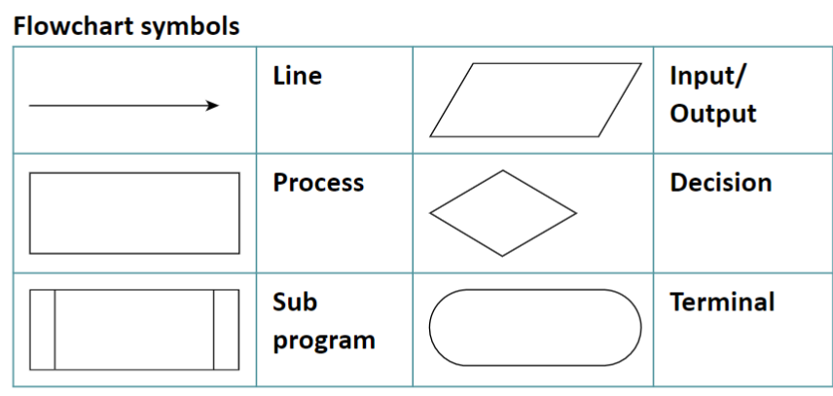
2.1.3 - Searching and sorting algorithms
- Standard searching algorithms  - Binary search  - Linear search  - Standard sorting algorithms  - Bubble sort  - Merge sort  - Insertion sort | Required  - Understand the main steps of each algorithm  - Understand any pre-requisites of an algorithm  - Apply the algorithm to a data set  - Identify an algorithm if given the code or pseudocode for it  Not required  - To remember the code for these algorithms  - To remember Exam Reference Language for Merge Sort

2.2 - Programming fundamentals
2.2.1 - Programming fundamentals
- The use of variables, constants, operators, inputs, outputs and assignments  - The use of the three basic programming constructs used to control the flow of a program:  - Sequence  - Selection  - Iteration (count and controlled loops)  - The common arithmetic operators  - The common Boolean operators AND, OR and NOT | Required  - Practical use of the techniques in a high-level language within the classroom  - Understanding of each technique  - Recognise and use the following operators:  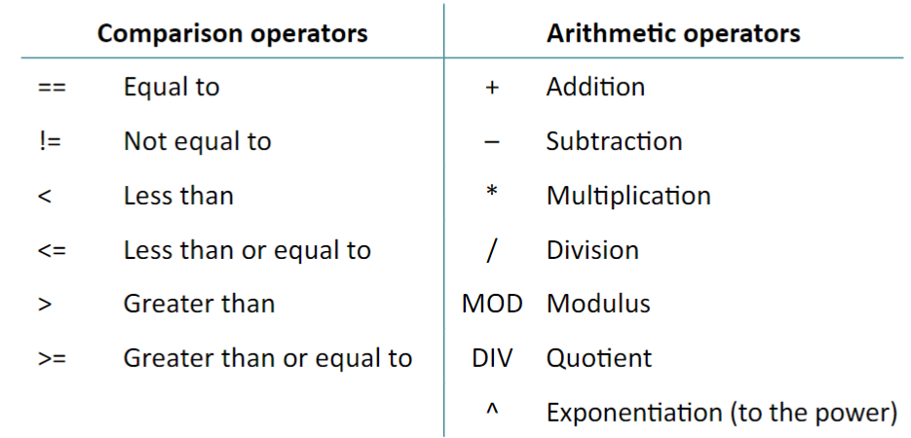

2.2.2 - Data types
- The use of data types:  - Integer  - Real  - Boolean  - Character and string  - Casting | Required  - Practical use of the data types in a high-level language within the classroom  - Ability to choose suitable data types for data in a given scenario  - Understand that data types may be temporarily changed through casting, and where this may be useful
2.2.3 - Additional programming techniques
- The use of basic string manipulation  - The use of basic file handling operations:  - Open  - Read  - Write  - Close  - The use of records to store data  - The use of SQL to search for data  - The use of arrays (or equivalent) when solving problems, including both one-dimensional (1D) and two-dimensional arrays (2D)  - How to use sub programs (functions and procedures) to produce structured code  - Random number generation | Required  - Practical use of the additional programming techniques in a high-level language within the classroom  - Ability to manipulate strings, including:  - Concatenation  - Slicing  - Arrays as fixed length or static structures  - Use of 2D arrays to emulate database tables of a collection of fields, and records  - The use of functions  - The use of procedures  - Where to use functions and procedures effectively  - The use of the following within functions and procedures:  - local/variables/constants  - global variables/constants  - arrays (passing and returning)  - SQL commands:  - SELECT  - FROM  - WHERE  - Be able to create and use random numbers in a program

2.3 - Producing robust programs
2.3.1 - Defensive design
- Defensive design considerations  - Anticipating misuse  - Authentication  - Input validation  - Maintainability:  - Use of sub programs  - Naming conventions  - Indentation  - Commenting | Required  - Understanding of the issues a programmer should consider to ensure that a program caters for all likely input values  - Understanding of how to deal with invalid data in a program  - Authentication to confirm the identity of a user  - Practical experience of designing input validation and simple authentication (e.g., username and password)  - Understand why commenting is useful and apply this appropriately
2.3.2 - Testing
- The purpose of testing  - Types of testing:  - Iterative  - Final / terminal  - Identify syntax and logic errors  - Selecting and using suitable test data:  - Normal  - Boundary  - Invalid / erroneous | Required  - The difference between testing modules of a program during development and testing the program at the end of production  - Syntax errors as errors which break the grammatical rules of the programming language and stop it from being run/translated  - Logic errors as errors which produce unexpected output  - Normal test data as data which should be accepted by a program without causing errors  - Boundary test data as data of the correct type which is on the very edge of being valid  - Invalid test data as data of the correct data type which should be rejected by a computer system  - Erroneous test data as data of the incorrect data type which should be rejected by a computer system  - Ability to identify suitable test data for a given scenario  - Ability to create/complete a test plan

2.4 - Boolean logic
2.4.1 - Boolean logic
- Simple logic diagrams using the operators AND, OR and NOT  - Truth tables  - Combining Boolean operators using AND, OR and NOT  - Applying logical operators in truth tables to solve problems | Required  - Knowledge of the truth tables for each logic gate  - Recognition of each gate symbol  - Understanding of how to create, complete or edit logic diagrams and truth tables for given scenarios  - Ability to work with more than one gate in a logic diagram  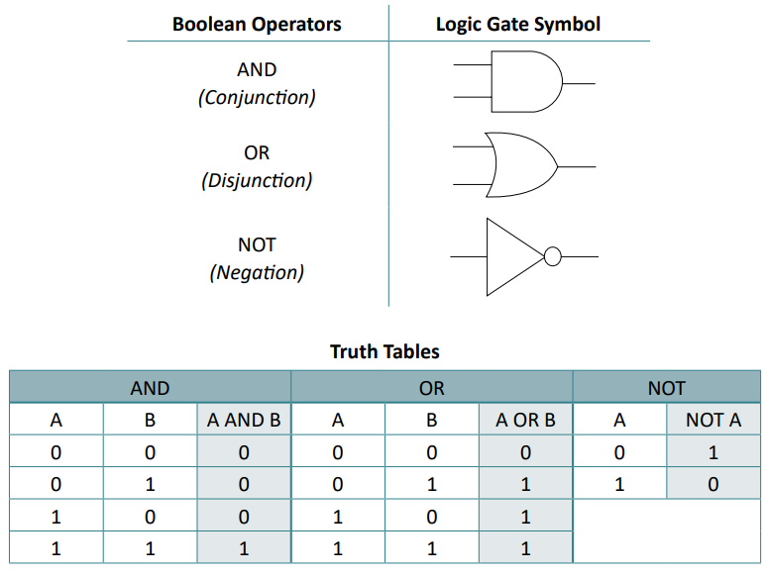  Alternatives:  - Use of other valid notation will be accepted within the examination, e.g. Using T/F for 1/0, or V for OR, etc

2.5 - Programming languages and Integrated Development Environments
2.5.1 - Languages
- Characteristics and purpose of different levels of programming language:  - High-level languages  - Low-level languages  - The purpose of translators  - The characteristics of a compiler and an interpreter | Required  - The differences between high- and low-level programming languages  - The need for translators  - The differences, benefits and drawbacks of using a compiler or an interpreter  Not required:  - Understanding of assemblers
2.5.2 - The Integrated Development Environment
- Common tools and facilities available in an Integrated Development Environment (IDE):  - Editors  - Error diagnostics  - Run-time environment  - Translators | Required  - Knowledge of the tools that an IDE provides  - How each of the tools and facilities listed can be used to help a programmer develop a program  - Practical experience of using a range of these tools within at least one IDE

