**Step 1 – Create your account on MyChildAtSchool**

Your account has already been created for you. However, some parents have not received the sign-up email and it has not appeared in their Junk Folder either.

Please follow these instructions in order to access your account.

* 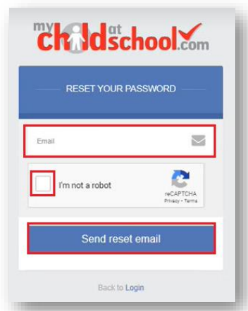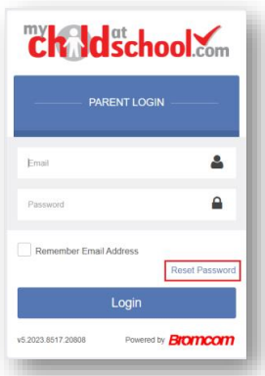From within the web browser, type [www.mychildatschool.com](http://www.mychildatschool.com) or access the **MyChildAtSchool** mobile phone app, this will open the **Parent Login** screen.
* Click on the **Rest Password** link.
* Enter the **Email Address**. This must be the  
  **Email Address** that the school uses to  
  contact you.
* Tick the **reCAPTCHA** box.
* Click on the **Send rest email** button.
* You will then receive an **Email**   
  containing a **Reset Password** link.
* 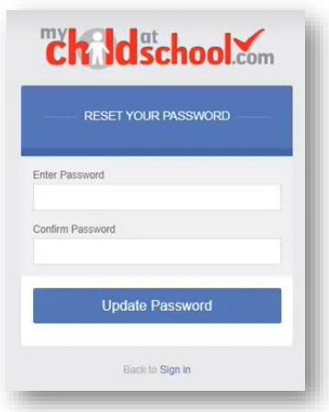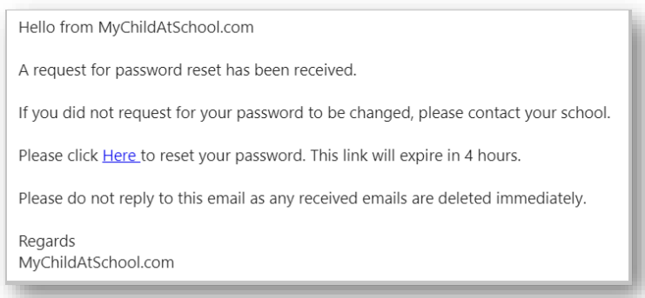Click on the **Here** link in the email to reset  
  the **Password**.
* You will then be asked to **Reset your Password** of at least eight characters.
* **Enter a new password**, then **Confirm Password** and then click the **Update Password button**.
* You will now be able to **login** using your **Email Address** and new **Password.**

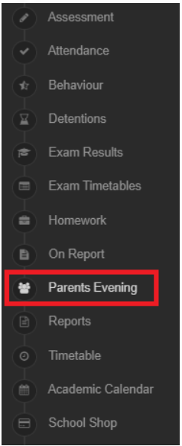

**Step 2 – Book your Parents’ Evening appointments**

* When you are on **MCAS**, you need to select **Parents Evening** from the side menu.
* This will then provide you with either a **Manual** or **Quick Book** option to secure  
  your Parents’ Evening **appointment**.
* To select a slot manually, you would click on the **Teacher** you would like to book an appointment with and then select **Book** next to the slot you would like to select.

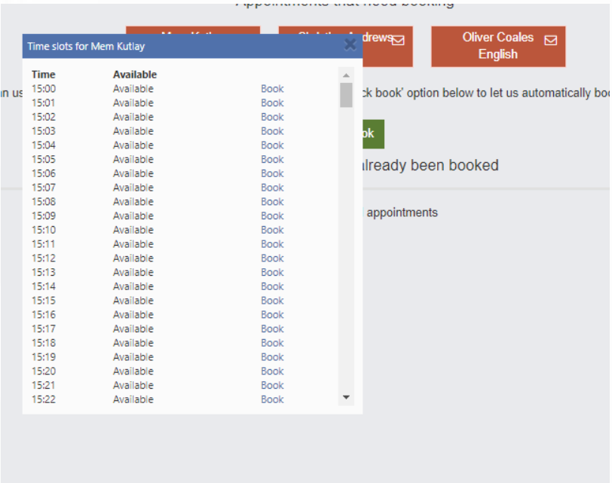

* To use **Quick Book**, you would select the time you will be arriving for the **Parents’ Evening** from the drop-down menu, and then click **Find Bookings.** The system will then display the appointments it has selected for you. If any are unsuitable, you can deselect them using the tick boxes on the right hand side, otherwise you would select **Book Appointments.**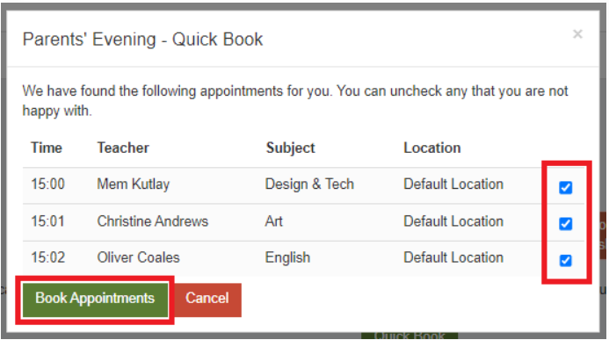
* You will then receive confirmation at the top of the screen that the appointments have been booked successfully.