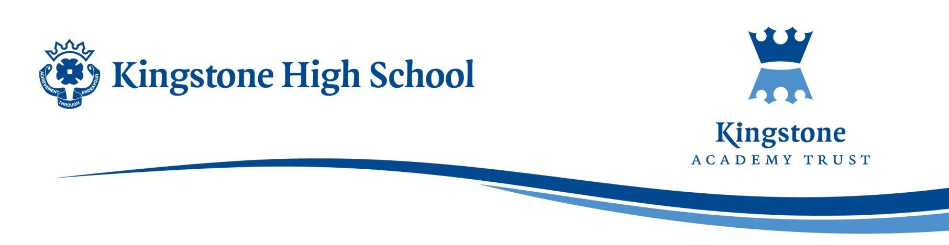

**KHS SKI TRIP 2026**

Dear Parent/Guardian,

We are delighted to announce the launch of another Kingstone High School Ski Trip.

|  |  |
| --- | --- |
| **Date** | **Saturday 28th March 2026 – Saturday 4th April 2026** |
| **Location** | **La Thuile, Italy** |
| **Hotel** | **Residence Planibel** |
| **Price** | **£1579 per person** |
| **Deposits &**  **Payment Schedule** | **£100 by 28th May 2025** |
| **£150 by 23rd July 2025** |
| **£332.25 by 30th September 2025** |
| **£332.25 by 31st October 2025** |
| **£332.25 by 30th November 2025** |
| **£333.25 by 1st January 2016** |

The students will travel on coach via the ferry to La Thuile, skiing will then start the morning after the arrival at hotel. The chosen hotel is a doorstep skiing resort which takes away the travel to the slopes, meaning students get more time skiing. Students will have five days of skiing before departure via the coach home.

The trip cost includes accommodation, breakfast and dinner at hotel, lunch on the slopes, ski passes, ski hire and ski lessons with experienced Interski staff. However, an additional fee will be added if your child requires ski jackets or salopettes hire.

This trip is a great opportunity to experience skiing for the first time or to develop your skiing on the advance slopes. Students will be in ski school with Interski staff for the 5 days, where they will be grouped based on their experience/abilities.

If this is something your child is interested in attending an initial deposit of £100 will need to be paid via ParentPay by 28th May 2025. This deposit doesn’t mean your child will automatically have a space on the trip. Your child will be notified with another letter explaining if they have been successful in gaining a space on the trip. Priority will be given to older KS3 students due to them not having the opportunity to ski again with school due to exams.

Kind Regards,

Miss Finch

Teacher of PE