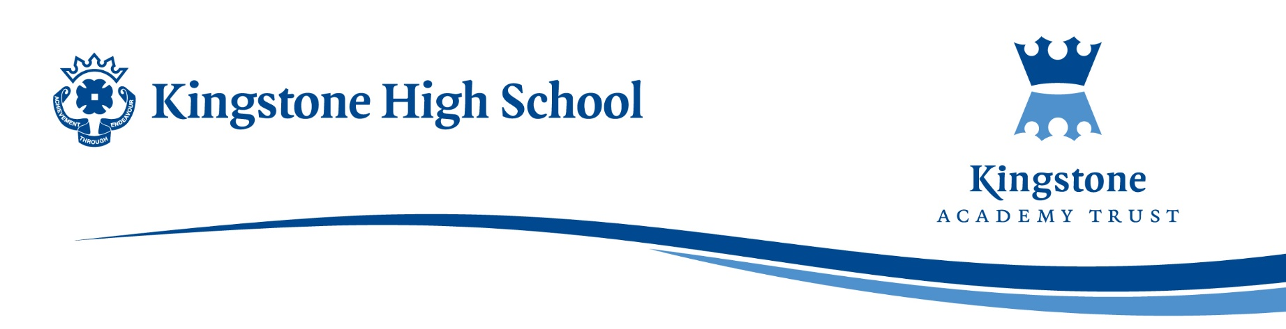

23rd February 2024

Dear Parents / Carers,

I am just writing to you to inform you of an exciting opportunity available for your child at the end of this academic year.

National Citizen Service (NCS) is an exclusive experience for 15–17-year-olds, giving them the opportunity to build skills for work and life on a 5 day away from home residential.

This is your child’s chance to get back out into the world with their friends, take part in new challenges and meet new people while gaining confidence and independence.

NCS away from home experiences are available across the country. Each experience is 5 days and 4 nights, and includes a variety of activities centred around one of three themes: LIVE IT, BOSS IT, or CHANGE IT. The experiences will boost your young person’s CV or their college or university applications, highlighting to employers and higher education providers the broader range of skills they’ve gained and their willingness to go beyond.

This year places are limited more than ever!

To find out more or how to sign your child up, check out the parent pack attached to this email or visit the NCS website <https://wearencs.com/head-away-from-home> to secure a place today!

The NCS team will be coming into Kingstone High School to present the away from home opportunities to our students on Wednesday 28th February 2024. We strongly encourage you to discuss this opportunity with your teen beforehand, so they are ready to express their interest and secure a place!

Thank you for taking the time to read this letter.

Yours faithfully,

Miss A Parker

Head of Year 11