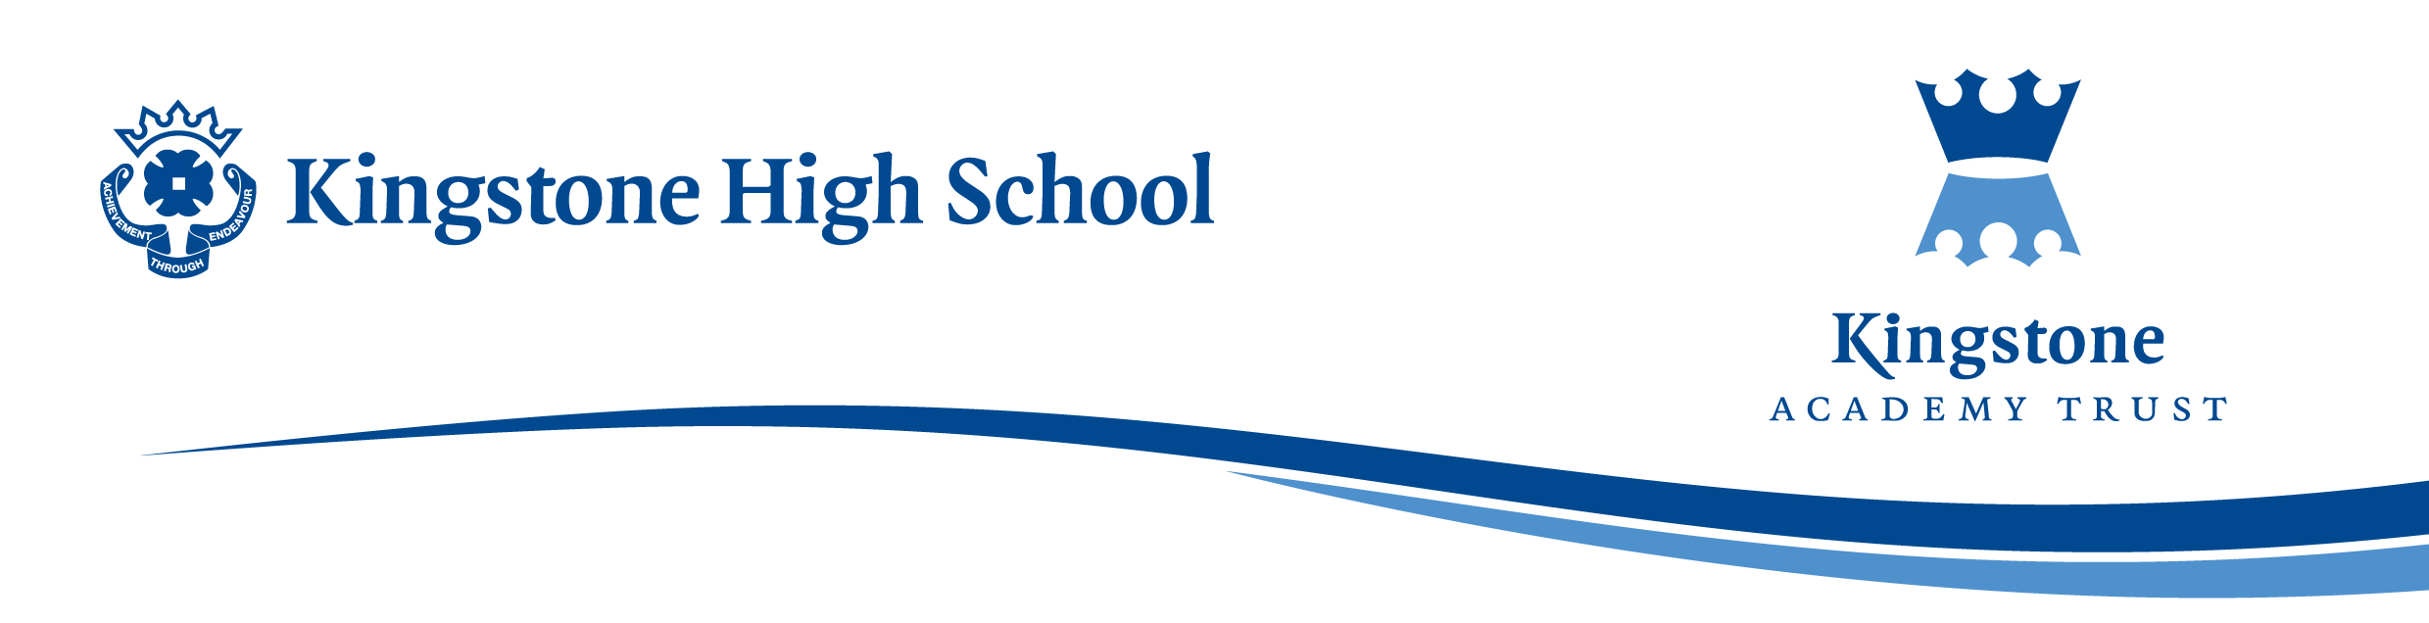

Monday, 24th February 2025

Dear Parents / Carers,

World Down Syndrome Day Friday 21st March 2025

We would like KHS pupils to join together and celebrate World Down Syndrome Day (WDSD) on Friday 21st March 2025, by wearing odd socks to school. Odd socks are a symbol for WDSD because chromosomes are shaped like socks and those with Down Syndrome have an extra one. Odd socks also highlight the fact that we’re all different and our uniqueness should be celebrated.

On this day, we will also be selling WDSD badges for £1 in the foyer at break and lunchtime to raise money for this charity.

Additionally, we would also like to hold a Chocolate Tombola on Friday 21st March. To make this a successful event, we kindly ask for any chocolate or sweet donations big or small which can be put into the raffle. For each chocolate donation, pupils will receive a positive point for kindness. Any donations should be brought to the TA office (next to the toilets) by Wednesday 19th March. Pupils will be able to buy raffle tickets on this day, 50p a go.

Many thanks in advance for your support and kind donations.

Yours faithfully

Mrs F. Harry & Mrs B. Roberts

