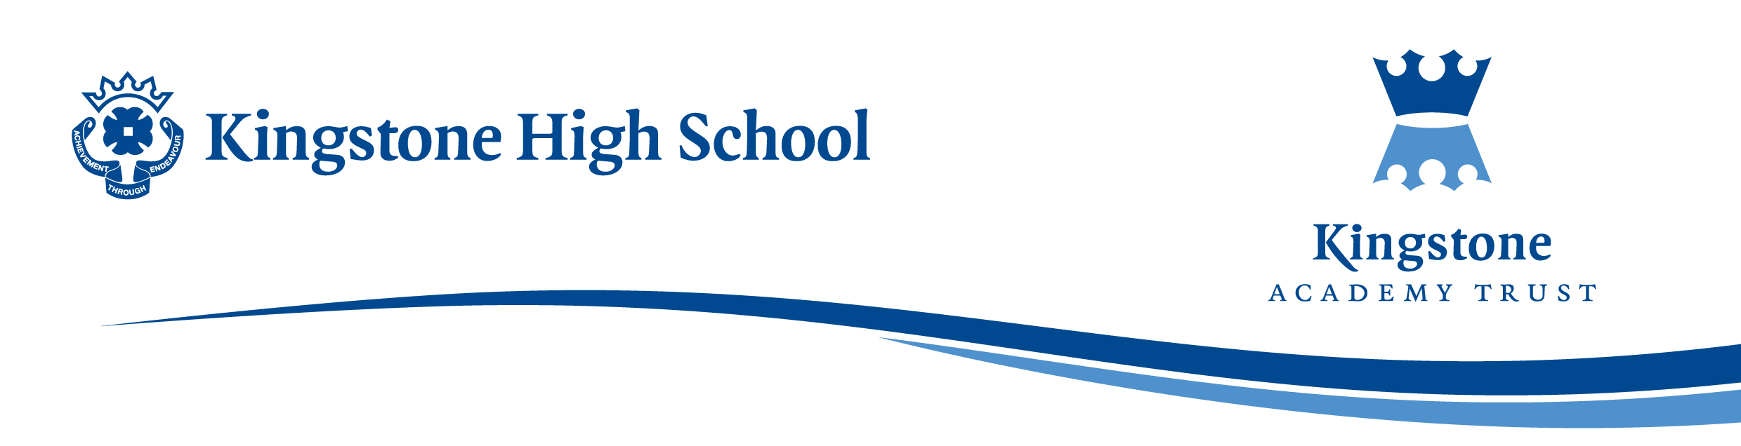

Thursday, 06 July 2023

Wednesday, 24 September 2024

Dear Parent / Carer,

The English Department would like to invite Year 7 students to enjoy an End of Term Christmas trip to New Theatre, Cardiff, to watch a pantomime production of Cinderella on Thursday 19th December 2024. Tickets have been provisionally booked at a cost of £31.00:

- Return bus journey
- Pantomime ticket for Cinderella

The departure time will be from school at 09:30am with the return being estimated at 17.30pm. Any student applying for the trip will need to make personal travel arrangements to accommodate the return time.

Assuming that we arrive in Cardiff at a suitable time, students should be able to have lunch at McDonalds which is located near to the theatre. Lunch is not included in the ticket price, so students will need to bring adequate monies for their lunch if they wish to purchase food at this outlet.

Please note that although the trip is open to all students in Year 7, it is paramount that excellent behaviour is maintained whilst off-site. Any student who applies and who has consistently not met the expected behaviour standards in school will be removed from the trip.

The Finance Department has kindly offered payment to either be in full (£31.00) or in two monthly payments.

- An initial payment of either £31.00 or £15.50 should be made on Parent pay by 15:30pm on Friday, 18 October 2024.
- The second and final payment of £15.50 to be make on Parent Pay by 15:30pm on Friday, 18 November 2024.

Any Free School Meal or Pupil Premium students can be offered financial support. Please contact Mrs Chalk, Finance Office on 01981 250224.

It is important to note that once the application is made and accepted, there will be no refunds at any stage. This means that if a student changes their mind or is absent for any reason on the day of the trip it will not be possible to request a refund.

The closing date for application is Friday, 18 October 2024.

Yours sincerely,

Miss S Reeves
English Department

